Technical Specification
Cigna Corporation
RPD Changes for Current liability

Author: Raghava Reddy Sitha/Lakshmi Supriya
Creation Date: April 21, 2016
Last Updated: April 21, 2016

Title, Subject, Last Updated Date, Reference Number, and Version are marked by a Word Bookmark so that they can be easily reproduced in the header and footer of documents. When you change any of these values, be careful not to accidentally delete the bookmark. You can make bookmarks visible by selecting the Office Button>Word Options>Advanced> and checking the Show bookmarks option in the Show document content region.

Approvals:
Vinay Pachika
Park Christine
To add additional approval lines, press [Tab] from the last cell in the table above.
You can delete any elements of this cover page that you do not need for your document.

Contents
1 Technical Overview 3
1.1 RPD Changes: 3
1.1.1 RPD Changes 3
1.2 ETL Changes 4

Technical Overview

RPD Changes:

RPD Changes

In BMM Layer , Select CORE Business Model ->Right Click the Fact - Preallocation Expenses Logical Table and select Current Liability Column Object

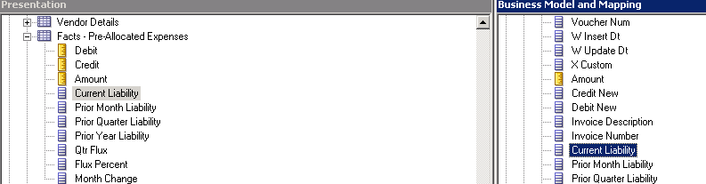

Select Default aggregartion rule as “SUM”

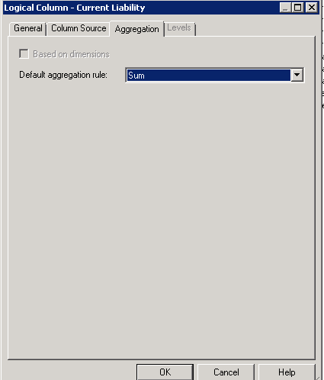

After the changes Current Liability column will display as shown below.

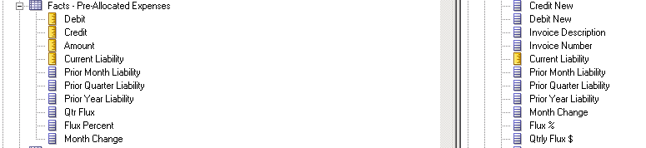

ETL Changes
Go to Designer Tab-> Mappings->Custom_SDE_Adaptor ->SDE_WC_P1_stage_Preallocexpensefact->SDE_WC_Preallocfact.WC_PREALLOC_FS_SQ_DISTRIBUTION_LINKS and SDE_WC_PreallocFact..WC_PREALLOC_SQ_XLA_DISTRIBUTION_INCR
Before Current Liability Calculation :
SQ_XLA_AE_LINES_HEADER.CURRENT_LIABILITY

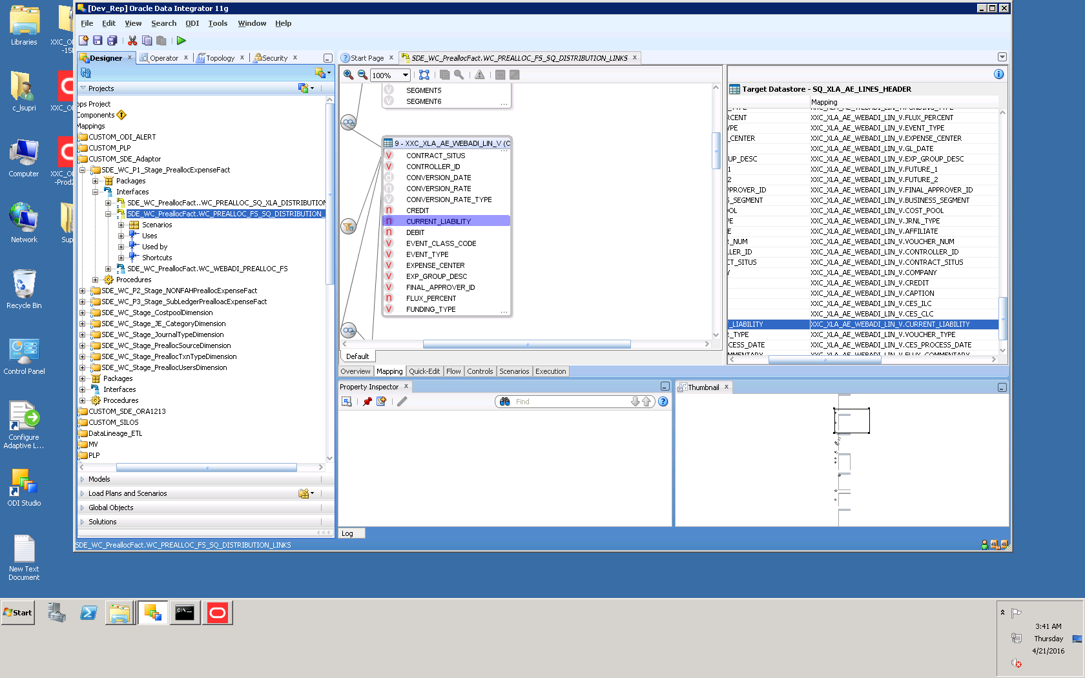
After Change Current Liability formula:

Below formula should be added in both the inetrfaces
- SDE_WC_Preallocfact.WC_PREALLOC_FS_SQ_DISTRIBUTION_LINKS
- SDE_WC_PreallocFact..WC_PREALLOC_SQ_XLA_DISTRIBUTION_INCR

(NVL(SQ_XLA_AE_LINES_HEADER.Debit, SQ_XLA_AE_LINES_HEADER.Credit*(-1)))

